Unlock Your Next Chapter
The Free Guide to Elevate Your Life

________________________________________

SheCredible Coaching
Ignite. Empower. Elevate.
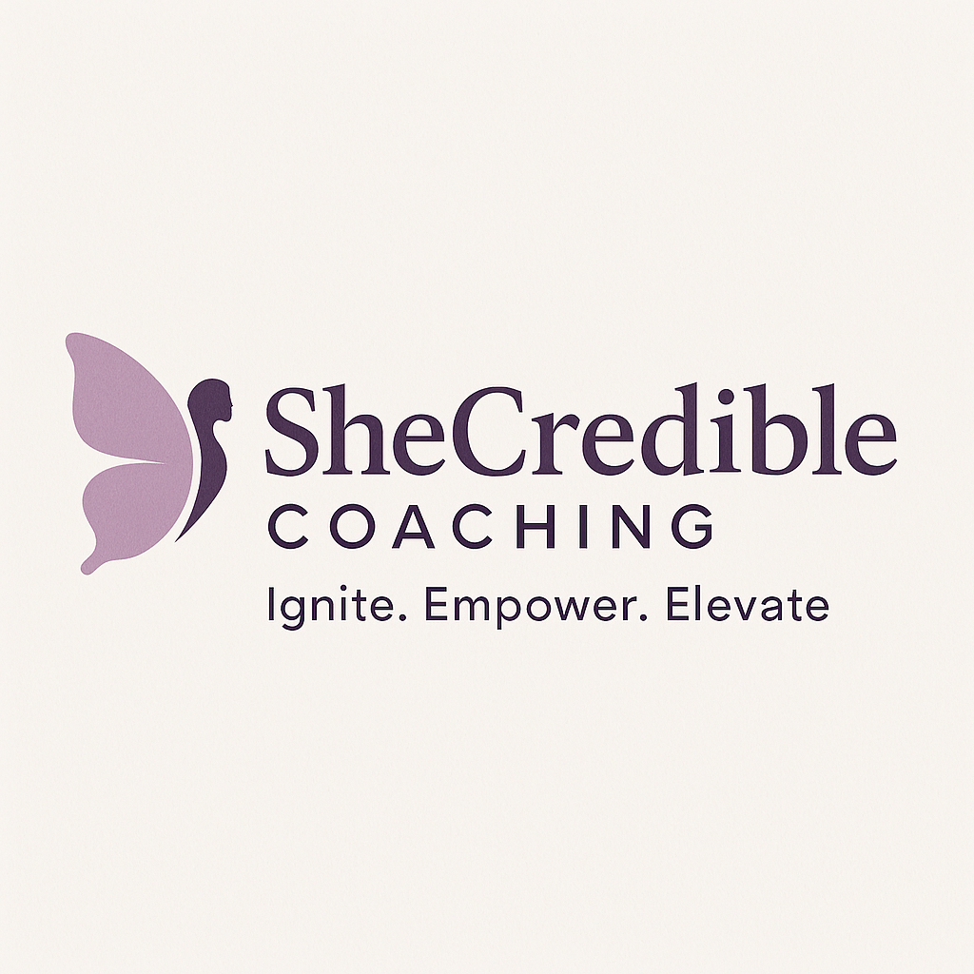

Unlock Your Next Chapter
The Free Guide to Elevate Your Life

Welcome, Beautiful! Your Next Chapter Starts Here.
Congratulations on saying “yes” to yourself. You didn’t stumble on this guide by accident—you’re here because you know there’s more inside of you. This is your moment to pause, reflect, and unlock the next chapter of your life with dignity, clarity, and confidence.
I created this guide to help you identify what’s been holding you back, rediscover your purpose, and build unstoppable momentum toward the life you deserve. Inside, you’ll find simple strategies, journaling prompts, and practical tools designed to help you step boldly into your next chapter.
Cheering you on,
Coach Udunna Founder,
SheCredible Coaching

Recognize the Mindset Blocks Holding You Back
Before you step into your next chapter, you must first identify what’s keeping you from moving forward.
We often stay stuck in transition because of limiting beliefs like: ‘I’m not ready,’ ‘I don’t have enough experience,’ or ‘What if I fail?’ These beliefs keep us from moving forward. Awareness is the first step.
Reflection Prompt: Can you identify with any of these common blocks women in transition face:
- Fear of failure – worrying “What if I try and don’t succeed?”
- Comparison trap – measuring yourself against others instead of your unique journey
- Overthinking – analyzing so much that you take no action
- Self-doubt – questioning your worth and ability to succeed

Action: Write down one belief you’ve been repeating to yourself that no longer serves you. Ask: Is this belief true? Or is it a barrier I can choose to let go of? Write new affirmations to replace them.

Simple Strategies to Rediscover Your Purpose
Purpose isn’t about titles or roles, it’s about alignment with your values, passions, and calling. It isn’t something you find, it’s something you uncover within yourself.
Think about what lights you up, where your strengths lie, and how you want to make an impact
Reflection Prompt: To rediscover your purpose, ask yourself:
- What activities make me feel most alive?
- What strengths do others naturally see in me?
- What do I want my life to stand for?
Action: List 3 things that light you up and make you feel alive and aligned with your values. These are clues to your next chapter.

A Step-by-Step Framework to Create Forward Momentum
Momentum comes from taking consistent, small steps. Even when you don’t feel ready, action creates clarity. Think of momentum as a ladder, each step builds on the last.
Reflection Prompt: A simple 3-step framework:
Step 1: Clarify – Define what you truly want. Not what’s “safe,” but what feels aligned.
Step 2: Commit – Take one small, bold step. Progress builds confidence.
Step 3: Cultivate – Surround yourself with accountability, encouragement, and tools to stay consistent.
Action Step: Write down one decision you’ve been delaying. Commit to a deadline for making that decision this week.

Tools to Rebuild Your Confidence and Gain Clarity
Confidence is not the absence of fear; it’s moving forward despite fear. It doesn’t come from knowing everything; it comes from showing up, even when it’s uncomfortable.
Clarity comes when you take intentional steps, not when you wait for perfect conditions. It grows as you take action and reflect on your progress
Reflection Prompt: How can you honor your journey, embrace your growth, and step into your next chapter with dignity and confidence?
Action: 3 ways to build confidence right now:
1. Celebrate small wins – Track your daily progress, no matter how small.
2. Speak truth over yourself – Replace “I can’t” with “I am capable and worthy.”
3. Stay connected – Don’t walk this journey alone. Community fuels courage.

Each day, write down one win (big or small) to remind yourself that you are capable and INCREDIBLE!

Your Next Step
This guide is just the beginning. You’ve unlocked tools to begin shifting your mindset, rediscovering purpose, and creating momentum but lasting transformation happens with guidance, accountability, and support.
That’s why I’d love to invite you to a Free 20-minute Breakthrough Call.
On this call, we’ll:
- Identify the #1 thing keeping you stuck
- Map out a personalized path to your next chapter
- Clarify how SheCredible Coaching can support you in your journey
Because with SheCredible Coaching, you don’t just imagine change; you live it because you are INCREDIBLE! And you are worthy of dignity, clarity, and elevation.
Cheering you on,
Coach Udunna
Founder, SheCredible Coaching

